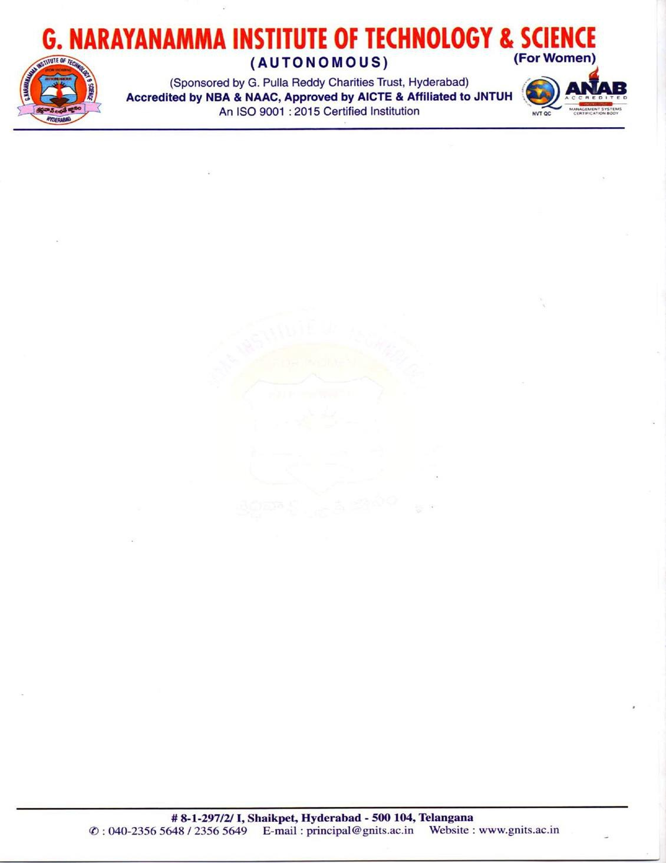

**CERTIFI CATE**

This is to certify that the project report entitled **SUSTAIN A PLATE Using React And PlayFrameWork** is bonafide work done by

**K SHIVANI (20251A12A5)**

**D HIMASRISAI (20251A3635)**

Under the guidance **of Dr I.Ravi Prakash Reddy Dean, Placements & Corporate Relations**, during **September 2023 to March 2024** in partial fulfillment for the award of degree in B.Tech in Information Technology, from G. Narayanamma Institute of Technology and Science.

Dr I.Ravi Prakash Reddy Dr.S.Ramacharan

**Internal Guide Head of the Department**

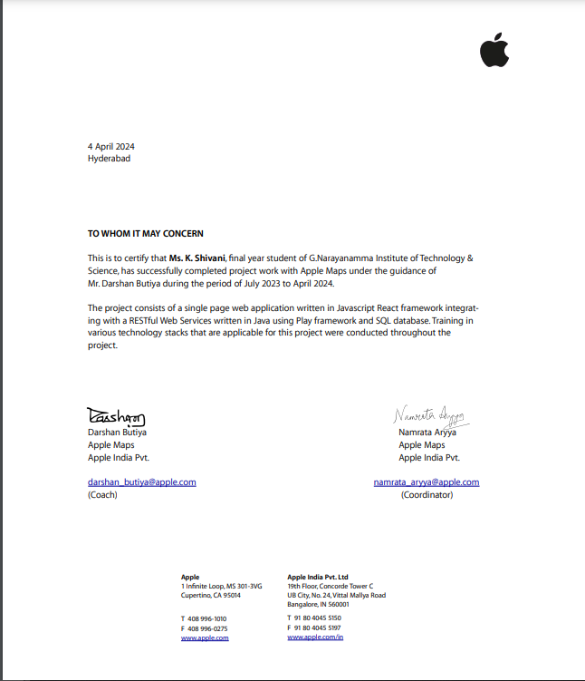

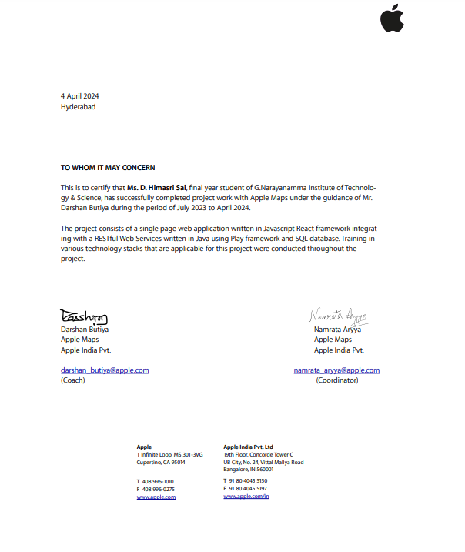



**Apple profile**

Apple Inc., a global technology giant, was founded in 1976 by Steve Jobs, Steve Wozniak, and Ronald Wayne. Since its inception, Apple has been synonymous with innovation, revolutionizing the consumer electronics industry with its iconic products and services.

At the core of Apple's success lies its diverse range of products, including the revolutionary iPhone, the versatile iPad, sleek MacBook, powerful iMac, stylish Apple Watch, and immersive Apple TV. Each device is meticulously designed to deliver a seamless user experience and is integrated within the Apple ecosystem, ensuring compatibility and ease of use across all platforms.

In addition to its hardware offerings, Apple provides a comprehensive suite of services aimed at enhancing user experience and enriching digital lifestyles. From the expansive App Store and convenient iCloud storage to the immersive entertainment experiences of Apple Music, Apple TV+, and Apple Arcade, the company's services cater to the diverse needs of its global customer base.

Apple's commitment to innovation is evident in its relentless pursuit of groundbreaking technologies. From the introduction of Touch ID and Face ID to the development of virtual assistant Siri and the transition to Apple Silicon chips, the company continues to push the boundaries of what's possible in the tech industry.

Throughout its storied history, Apple has left an indelible mark on the world, shaping the way we communicate, work, and play. With its dedication to excellence and forward-thinking vision, Apple remains at the forefront of technological innovation, inspiring generations to come.

**Acknowledgement**

We would like to express our sincere thanks to **Dr . K. Ramesh Reddy,** Principal of G. Narayanamma Institute of Technology and Science, for providing the good working environment and facilities in the college. A sincere gratitude to **Dr . S. Ramacharan**, Professor and HOD, Department of Information Technology , G. Narayanamma Institute of Technology and Science, for encouraging us to take up the project and all the timely support during the time of major project.

We are extremely thankful and indebted to our Internal guide, **Dr I.Ravi Prakash Reddy** Dean, Placements & Corporate Relations, Department of Information Technology, GNITS and project coordinators, **Dr.L.Smitha, Ch.Sravanthi**, Assistant Professors, Department of Information Technology, GNITS for their constant guidance, continuous advice, encouragement and moral support throughout the project.

Finally, we would also like to thank all the faculty and staff of Department of Information Technology who have helped us directly or indirectly, parents and friends for their cooperation in completing the project report work.

**Abstract**

With the burgeoning ease of sourcing food, the issue of food waste has multiplied. The irony is that both hunger and food wastage are increasing. It simply means that we don’t lack the food, but we lack the source to bridge the gap between the extra food and that of hungry folk. The solution is Food Waste Management System which addresses the critical issues of food waste and scarcity through a seamless and user-centric approach. The User module simplifies the donation process, allowing individuals and establishments to register easily and specify their food contributions. The Administrator module, tailored for trusts and NGOs, efficiently manages the distribution process by listing incoming donations and enabling organizations to select based on their needs. This collaborative effort optimizes resource allocation, minimizing food waste and ensuring donations reach those in need.

The Delivery Person module serves as the logistical bridge, engaging individuals for pickup and delivery services. This module streamlines the transportation of donated food, providing essential details to NGOs and charities. In essence, the Food Waste Management System combines technological innovation with a compassionate approach, fostering a community-driven solution to efficiently connect surplus food with those who need it most.

**CONTENTS**

**1. INTRODUCTION**

* 1. General / Domain Description…………………………………………….....1
  2. Objective & Scope of the Project………………………………………….....4
  3. Project Definition………….............................................................................6
  4. Organization of Project Report……………………………………………....6

1. LITERATURE SURVEY
   1. Existing Approaches / System……………………………………………….7
   2. Drawbacks in Existing System……………………………………………………………………….10
   3. Motivation for Proposed System……………………………………………………………………….11
2. REQUIREMENT SPECIFICATION
   1. Introduction………………………………………………………………….12
   2. System Environment………………………………………………………………...12
   3. Functional Requirement Specification

3.3.1.Use case description ……….............................14

3.3.2.List of Functional Requirements………………24

* 1. Non-Functional Requirements…………………………………………….………………….25
  2. H/w &S/W requirements……………………………………………….………………..26
  3. System Architecture…………………………………………………..……………..28

1. DESIGN SPECIFICATION
   1. Overall Use case Diagram……………………………………………………………………..29
   2. ER diagrams with Normalized Databases ………………………………….32
   3. Class Diagrams…………………………………………………………………….34
   4. Activity / State chart diagrams…………………...………………………….38
   5. Sequence Diagrams………...………………………………………………..36
   6. Collaboration/Deployment Diagrams………..……………………………...37
2. IMPLEMENTATION
   1. Methodology …………...…………………………………………...………40
   2. System Architecture …………………….………………………………......42
   3. Module Description ……………………………………………………..….42

# TESTING

* 1. Test Plan …...…………...………………………………………..…………44
  2. Test Cases ……………………………….………………………..………...46

# RESULT AND CONSLUSIONS

# Result Analysis/Performance Analysis………………………………………49

# Conclusion and Future Scope …………………………………………………... 50

**Appendix**

1. Screenshots representing the flow of your project work …………. 53
2. Code ……………………………………………………………..…61
3. Bibliography/References ……………………………………....…. 79

**LIST OF FIGURES**

**Figure No. Figure Description Page No.**

# 3.6 System Architecture 29

# 4.1 Use case Diagram 33

# 4.2 E-R Diagram 35

# 4.3 Class Diagram 37

# 4.4 Activity Diagram 38

# 4.5 Sequence Diagram 40

# 4.6 Collaboration Diagram 42

# 4.7 Flow Chart Diagram 41